Assignment 5- ER Diagram/Data Modelling

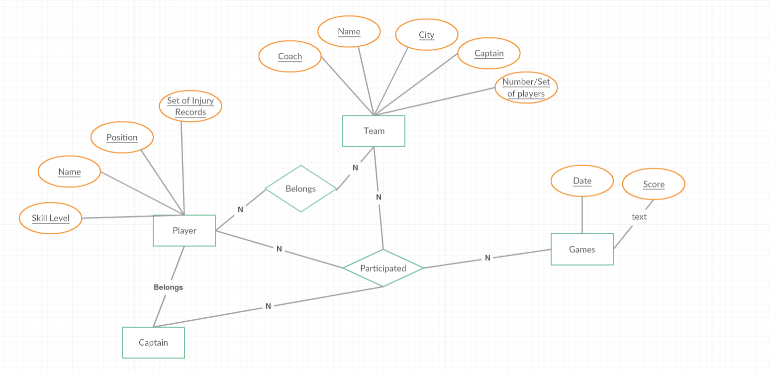

NHL-National Hockey League -ER Diagram